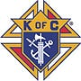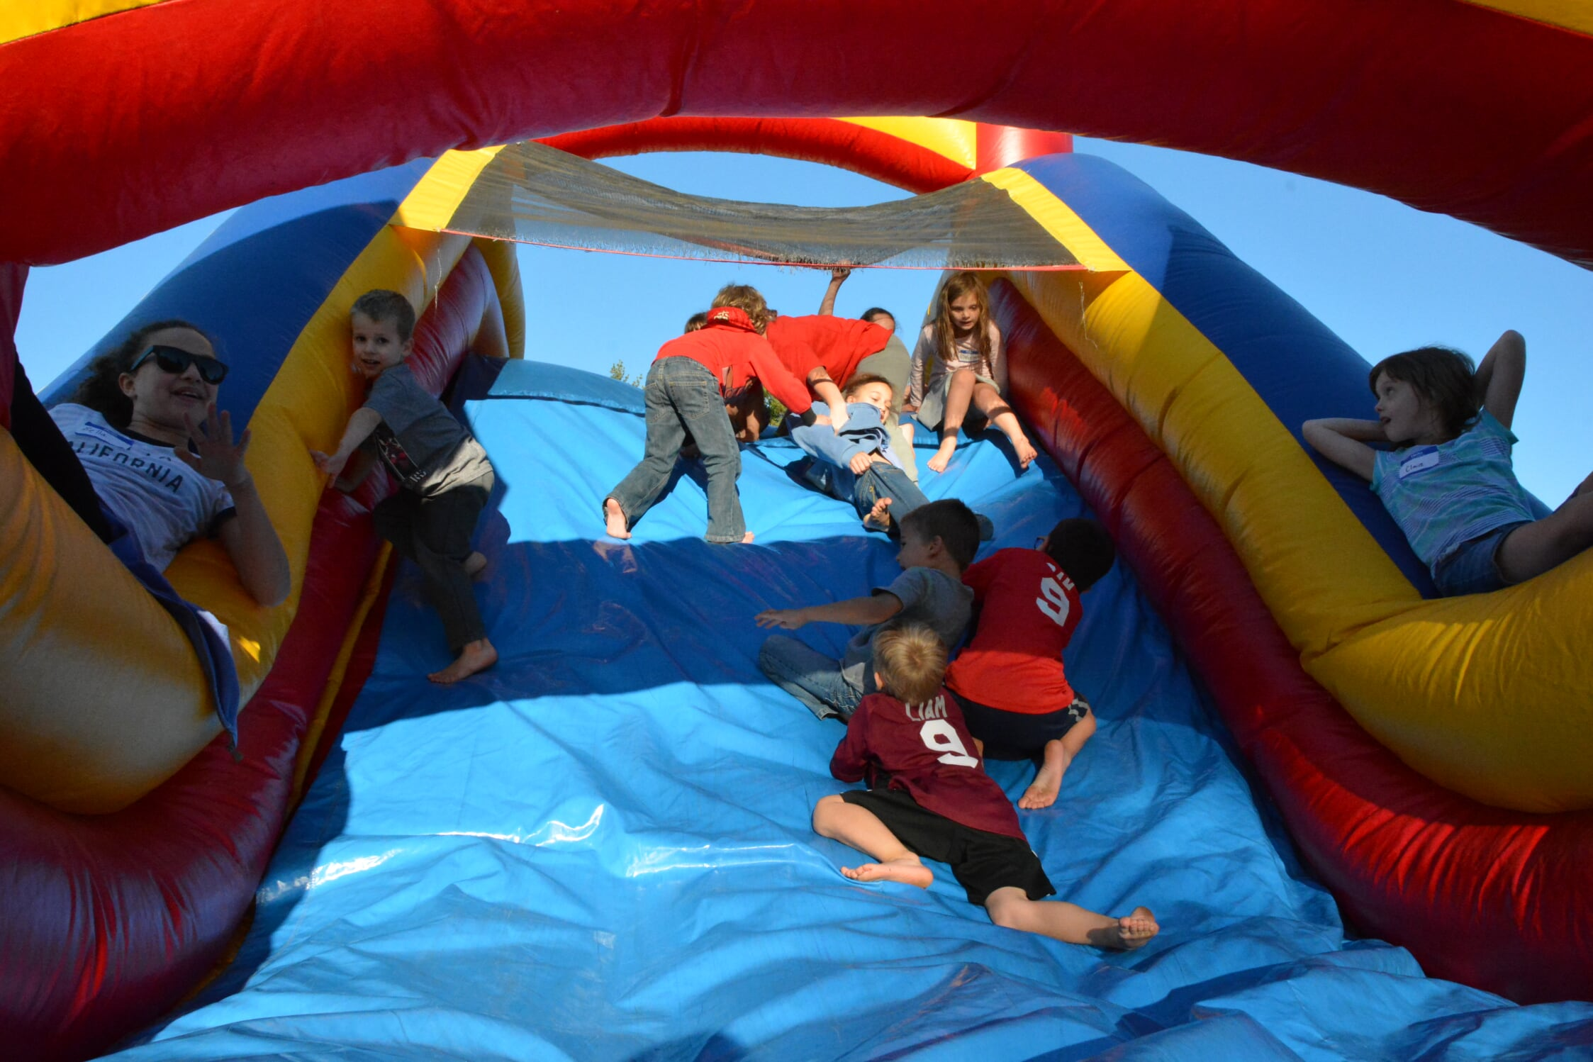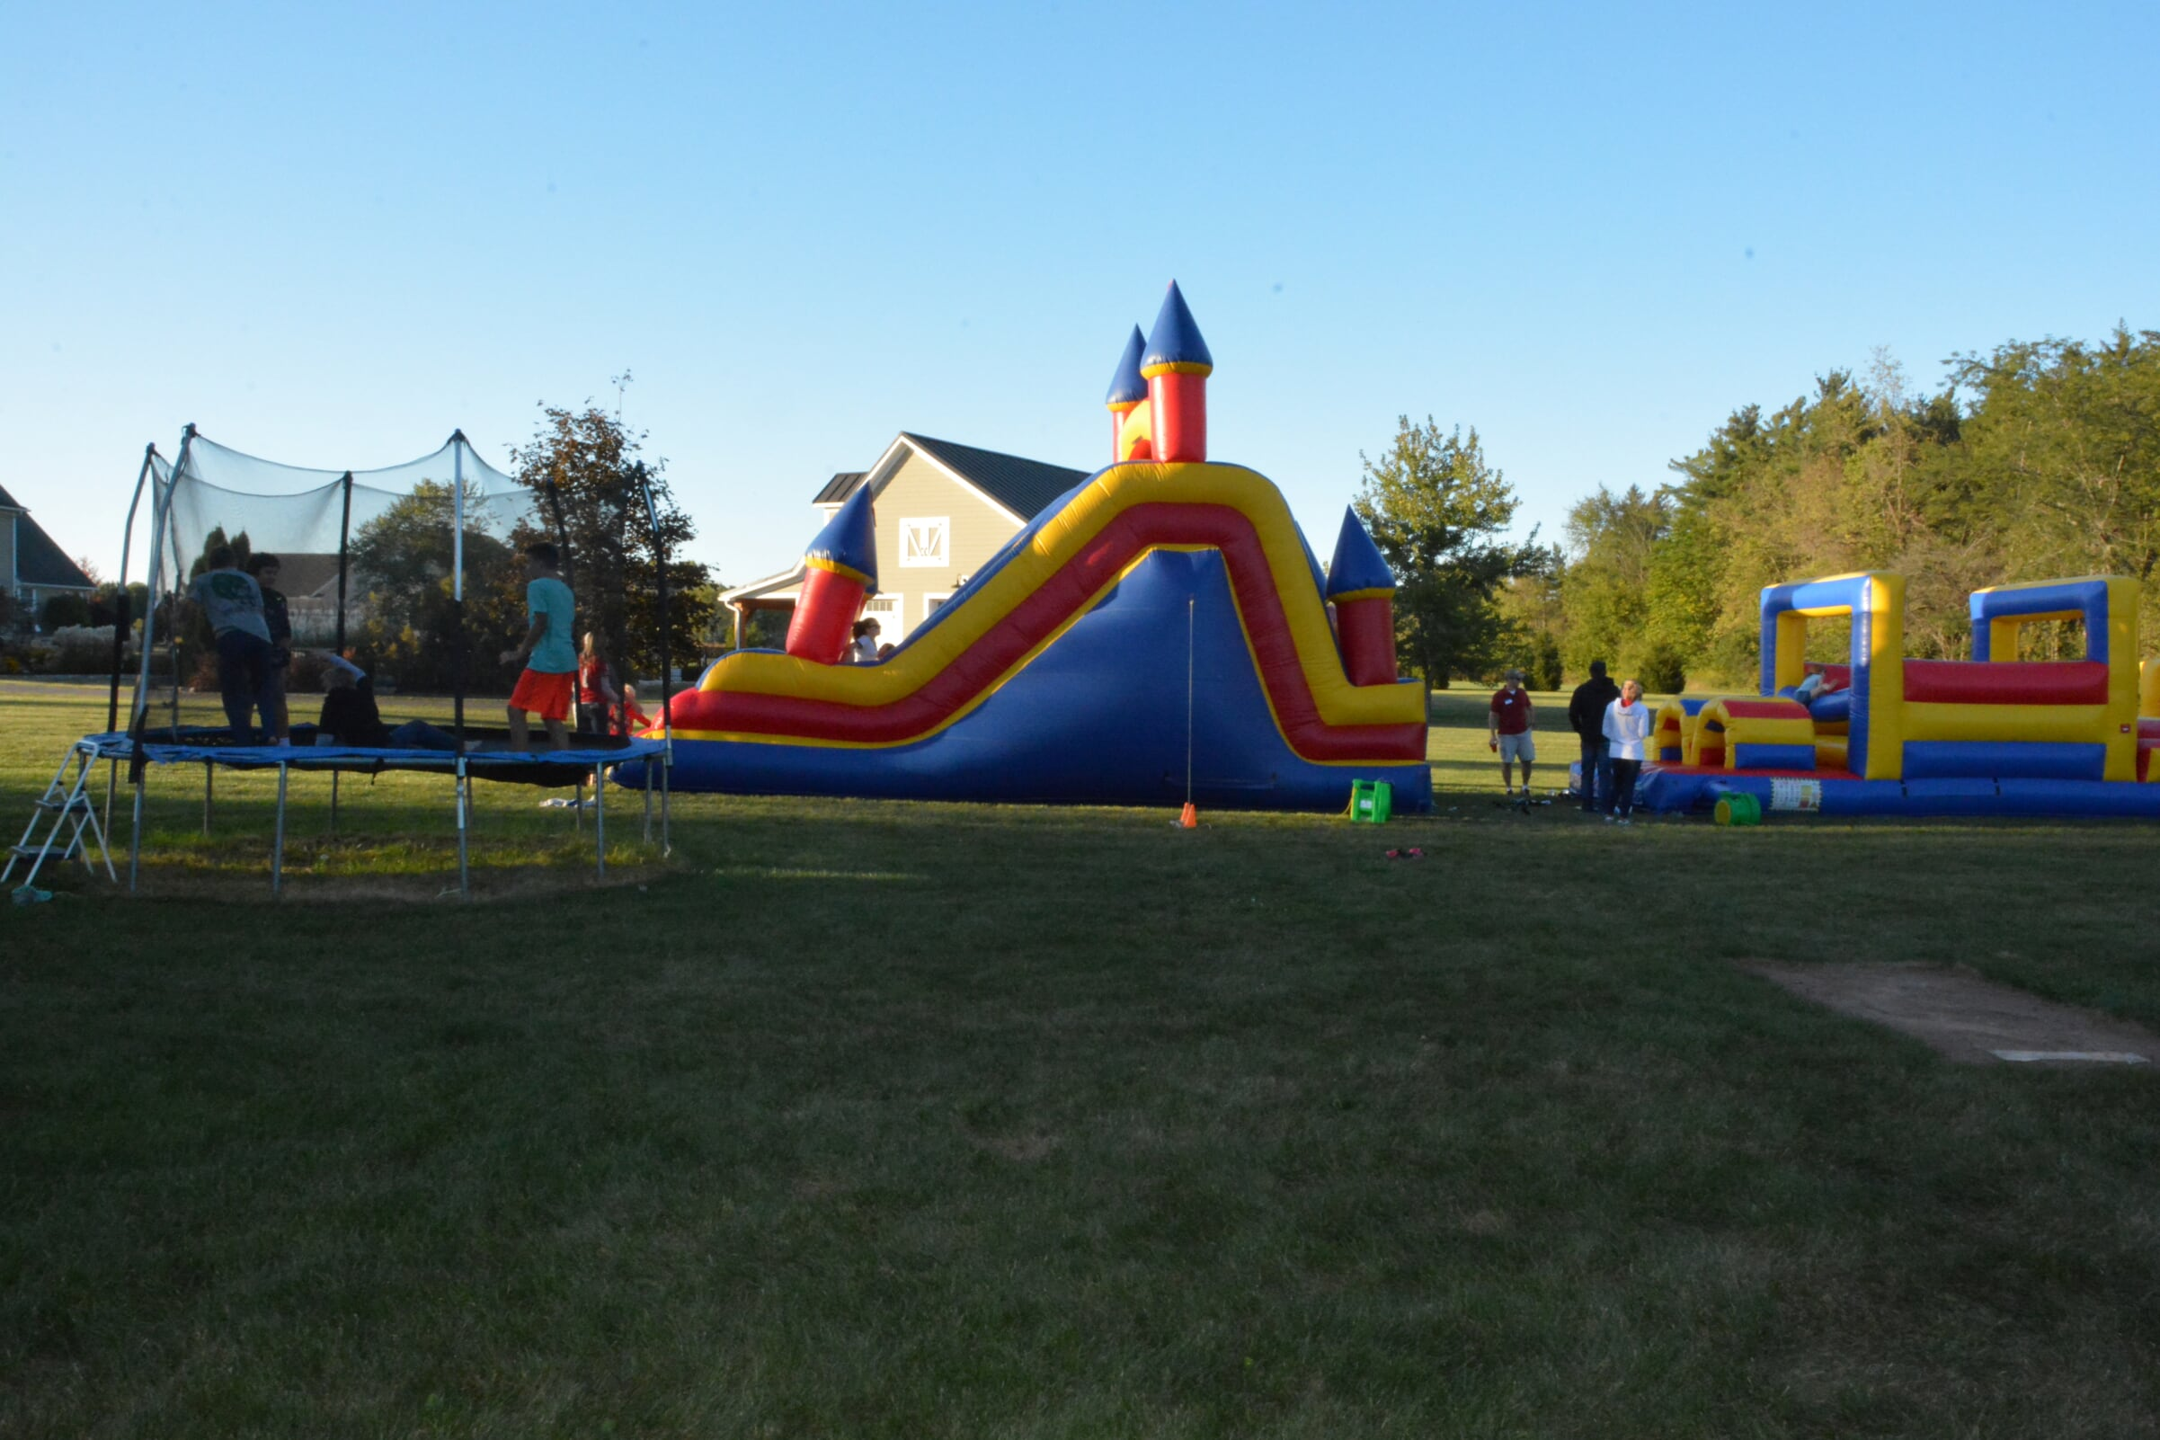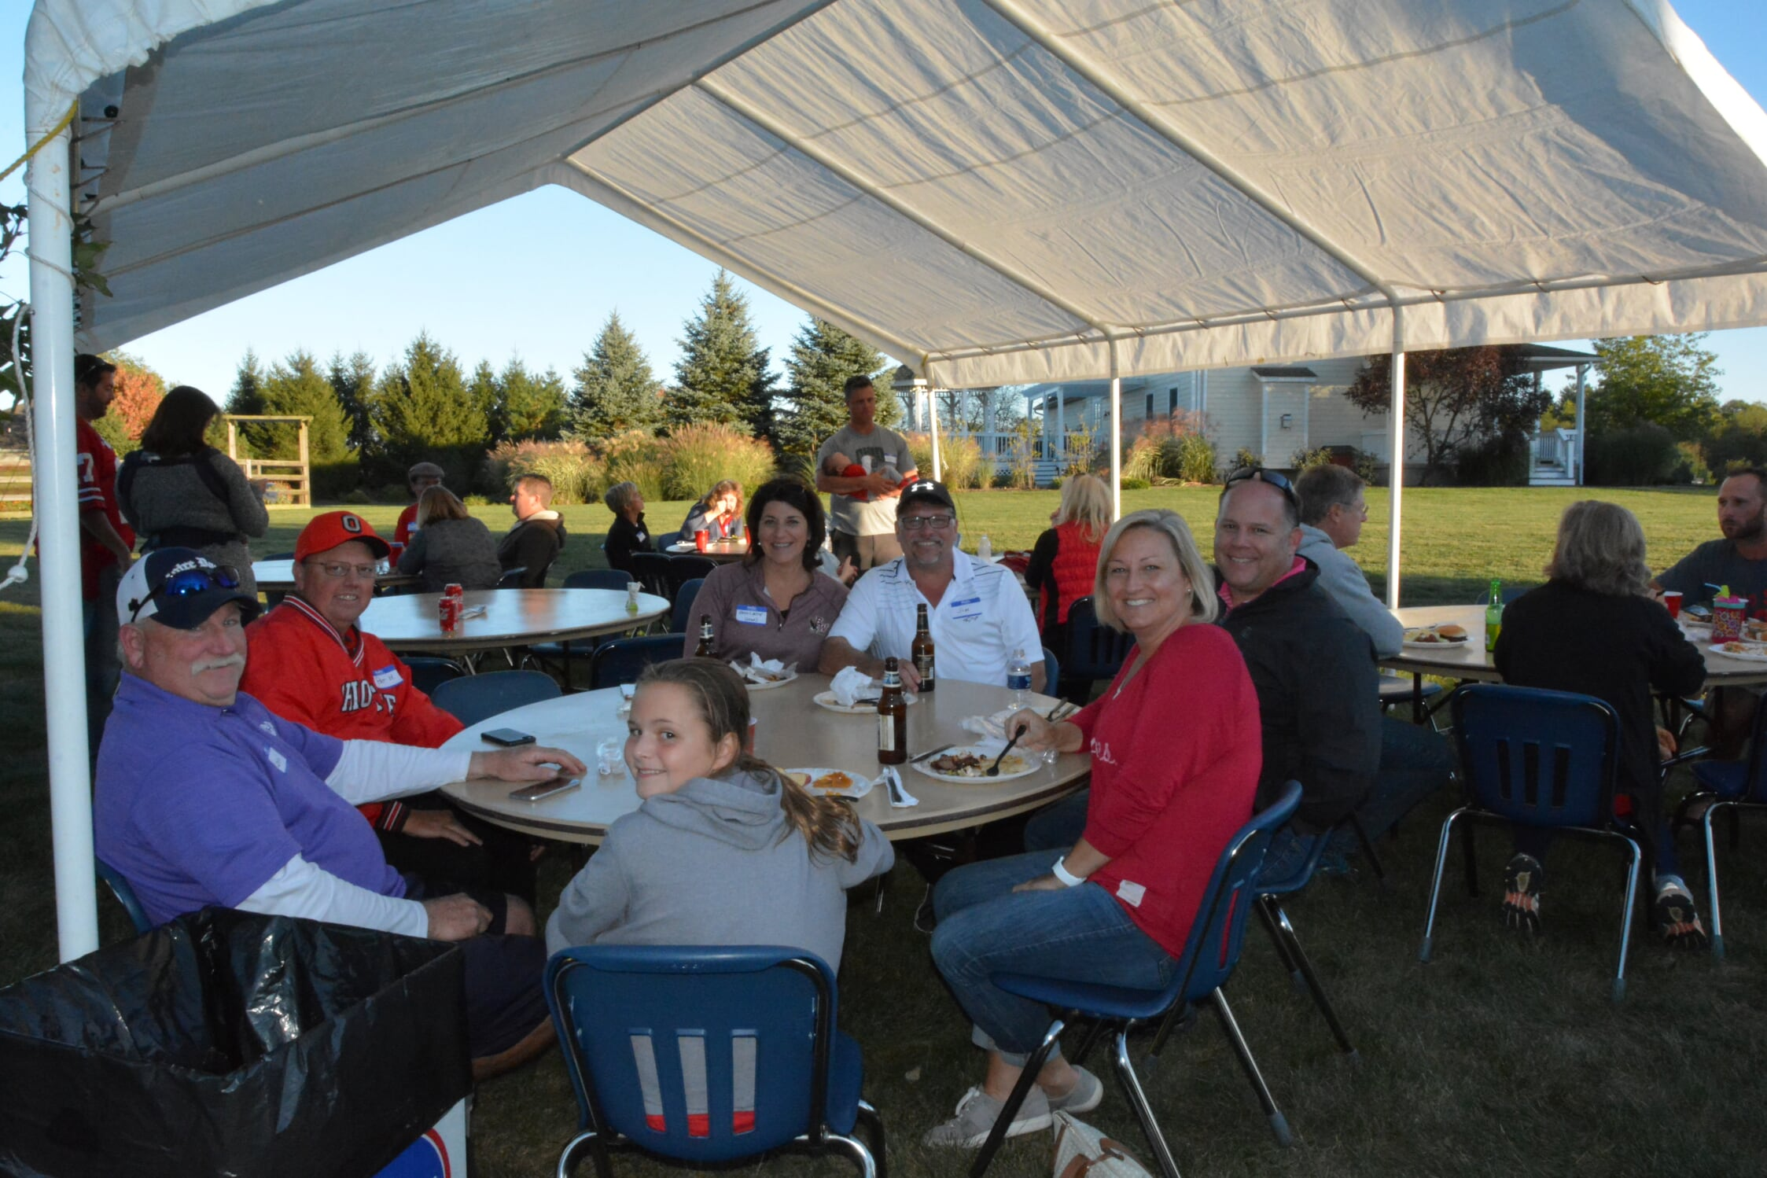
8th Annual 2022 Knights Family Picnic & Golf Tourney Social
Join your fellow Knights and their families and socialize with food, fun, and fellowship at the Knights Family Picnic and Golf Tournament Social!!
When: Saturday, September 17, 2022 3:00pm - ?? RSVP by: September 3, 2022 to Todd Pepe at pepnbuff@gmail.com, call (740)972-5777 or signup here RSVP to Picnic
Where: Fellow Knight Todd Pepe’s house at:
6484 Blarney Stone Way
Delaware, OH 43015 (Just North of Home Rd)
Food: Enjoy ONSITE Smoked Beef Brisket and Chicken Wings, Grilled Hamburgers, Brats, and Hot Dogs! Please feel free to bring your favorite side dish and/or dessert to share. Water and soft drinks will be provided.
**Due to varying tastes & selections, we ask that you BYOB
Fun: Let the kids tire themselves out on the 20’ x 40’ inflatable obstacle course from Buckeye Bounce Houses. Other activities include:
- Cornhole | - Volleyball
- Badminton | - Large Screen for Football
- Raffle | - Campfire for Smores
Requests: Requesting tables and chairs and AV Equipment and Cornhole Sets Contact Todd Pepe at pepnbuff@gmail.com or (740)972-5777 with questions, to RSVP, or if you’d like to offer up assistance and/or equipment.

