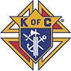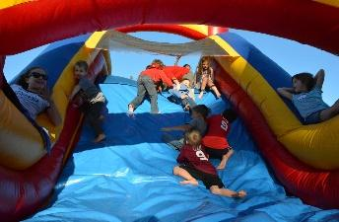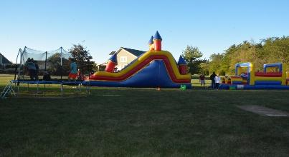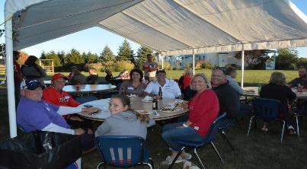

2024 Knights Family Picnic & Golf Tournament Social
Join your fellow Knights and their families and socialize with food, fun, and fellowship at the Knights Family Picnic and Golf Tournament Social!!
When: Saturday, September 14, 2024 from 3:00pm - ??
RSVP by: August 31, 2024 to John Greco at jgreco7779@gmail.com, call/text (330)509-3979 or signup here RSVP to Picnic
Where: PGK Tim Solak’s house at:
8025 Dublin Rd
Dublin, OH 43017
Food: Enjoy Smoked Beef Short Ribs, Chicken Wings, Grilled Hamburgers, Brats, and Hot Dogs! Please bring your favorite side dish and/or dessert to share. Water and soft drinks will be provided.
**Due to varying tastes & selections, we ask that you BYOB
Fun: Let the kids tire themselves out on the 20’ x 40’ inflatable obstacle course from Buckeye Bounce Houses. Other activities include:

- Cornhole | - Volleyball
- Badminton | - Football watch party
- Raffle | - Campfire for S'mores
Requests: Please contact John Greco at jgreco7779@gmail.com or (330) 509-3979 with questions, to RSVP, or if you’d like to offer up assistance and/or equipment.

