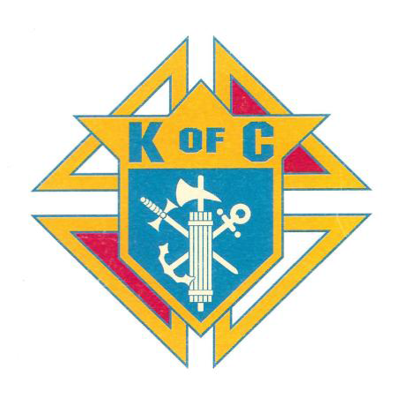

**Opportunity to Promote your Business**

**with Raffle Items and Golf Prizes**

**2024 SCHOLARSHIP FUNDRAISER & ANNUAL GOLF OUTING**

**September 14, 2024**

**Roma Memorial Golf Scramble and Raffle**

**All proceeds support the St. Brigid Knights of Columbus (Council 10863) Scholarship Fund. All High School Seniors that are Catholic and registered St. Brigid parishioners are eligible to apply for this scholarship…$3,000 in scholarship funds are awarded each year…four students receive $750 annually for four years**

**---------------------------------------------------------------------------------------------------------------------------------**

**How Can You Help?**

**Gift Certificates Gift Cards Gift Baskets Other Prize Contributions**

**---------------------------------------------------------------------------------------------------------------------------------**

**St. Brigid Knights of Columbus Tax ID# 20-3746092**

All gifts are considered charitable donations and 100% of funds raised support the scholarships

**---------------------------------------------------------------------------------------------------------------------------------**

**Contact with Questions**

**Terry Miller (614-327-1381 |** **terry@milcohealth.com****)**